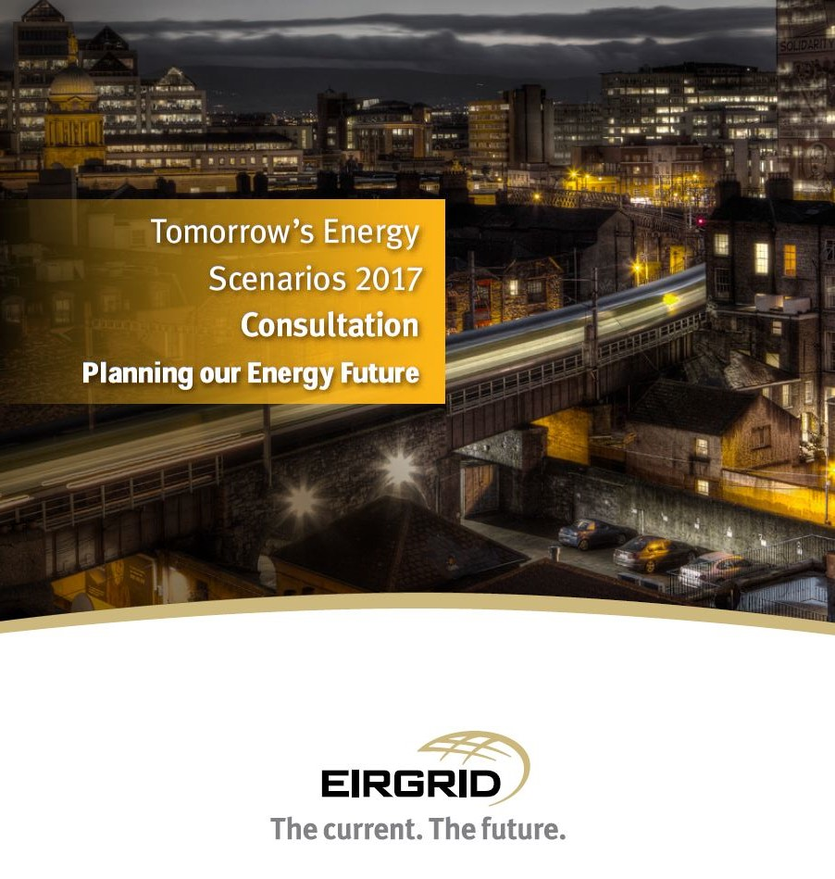

Tomorrow’s Energy Scenarios 2017 Consultation is the first step in the engagement process for ‘Planning our Energy Future’. To continue the conversation on our draft scenarios we would like to get your input on the future of energy in Ireland.
To gather this feedback we have posed some questions which you can find below. You can submit your answers online or by filling out this form and returning it to us by email to scenarios@eirgrid.com.
We will be accepting input and feedback on our draft scenarios until March 31st 2017.
To get further information on our draft scenarios please visit http://www.eirgridgroup.com/customer-and-industry/energy-future.
Alternatively, please email us your views on Tomorrow’s Energy Scenarios to scenarios@eirgrid.com and one of our team will be in touch.
1. Details: (Optional)
Please provide an email address if you would like further information on the development of Tomorrow's Energy Scenarios in future.

Name: Gary Healy
Organisation: Irish Wind Energy Association
Email Address: gary@iwea.com

2. Do you feel the Tomorrow's Energy Scenarios 2017 Consultation document has helped you better understand the future possibilities of Ireland’s energy industry?

☒ Yes ☐ No ☐ Unsure

Please provide details on the reasons for your choice:
IWEA welcome eirgrid’s work on future scenarios and believes this is a vital time for discussion of the future direction of the Irish energy market as we consider the EU 2030 Clean Energy package.

3. Do you feel the Tomorrow's Energy Scenarios 2017 Consultation document has helped you understand the link between electricity supply and demand and the future needs of the electricity grid?

☒ Yes ☐ No ☐ Unsure

Please provide details on the reasons for your choice:
IWEA believes the demand assumptions are important to consider particularly as demand growth and management will drive the nature of electricitiy supply and in particular the growth of renewables on the system.
IWEA welcomes the focus on demand management and the need to, where possible, enable smart metering and consumers such as data centres where the demand can be smoothed away from peak use time. IWEA believes it is important to factor electricification of heat and transport generally and the demands on the electricity network from these newer sources of demand ito scenario planning

4. Which draft scenario do you believe is the most likely scenario? (Please choose one)

☐ Steady Evolution
☒ Low Carbon Living
☐ Slow Change
☐ Consumer Action

Please provide details on the reasons for your choice:
IWEA believes Ireland’s energy future is in clean technology and renewables.
At a national level, Ireland’s energy demand is expected to increase in the coming years through population growth and through economic growth including the development of data centres in Ireland, as outlined in the graph below. Ireland is currently heavily reliant on imported fossil fuels, with statistics from SEAI showing an 88% energy import dependency in 2015. As the global demand for energy is increasing with the increase in the global population, Ireland will be subject to international forces in price variability for fossil fuels. It is clear that there is a need to increase our energy independence to reduce our exposure to international price shocks, while at the same time ensuring a sustainable energy future.
IWEA believes that renewable energy has a significant role to play in Ireland’s energy future, and in increasing our energy independence. Renewable energy is already playing a significant role in the electricity sector, with 27.3% of our electricity being met by renewables in 2015, while at the same time delivering value to the consumer. There has been less progress in the areas of transport and heat, however some progress has been made. As we move to a decarbonised energy sector (as envisaged in the White Paper), we need to take a holistic view of the energy system, and to assess the role of renewables across the whole energy sector. The Clean Energy Package from the European Commission sets out the need for member states to identify the energy pathway to 2030.

5. Do you believe the draft scenarios are credible?
Yes No Unsure
Steady Evolution ☒ ☐ ☐
Low Carbon Living ☒ ☐ ☐
Slow Change ☐ ☒ ☐
Consumer Action ☒ ☐ ☐

Please provide details on the reasons for your choice:
IWEA believes that the most likely scenario given the current economic conditions, technological advances and EU policy requirements fits low carbon living. Eirgrid have in this scenario and in the steady evolution and Consumer Action scenarios given more focus to renewables as a larger part of the grid. IWEA welcomes for example the focus on a possible 65% RES-E target. IWEA believe we should be focused on a RES-E target of 70%.
As we approach 2020 we are seeking to have 40% of our electricity from renewables. The DS3 programme from EirGrid has been implemented to integrate this level of renewables. This has been an excellent piece of work to help us get this far and identify some of the technical challenges of integrating renewables on to a small island system. This work will need to be built on to get to even higher levels of renewables on the system out to 2030, 2040 and beyond.
Initial analysis carried out by IWEA shows that at 70% renewables on the system in 2030, without any technological developments/improvements (assuming DS3 has been delivered), curtailment of wind energy will be in the region of 23%. This is not a sustainable level of curtailment. In order to keep curtailment levels below 5% there are a number of issues to be resolved which we have identified:
- Minimum generation levels of conventional (in particular must-run) plant need to be reduced.
- Number of must run units may need to be further reduced.
- Further increase of SNSP (up to 85%) will be required.
- Higher levels of interconnection need to be investigated.
- Interconnector rules need to ensure renewable technologies can be facilitated.
- Impact of storage technologies needs to be analysed.
IWEA estimate that taking the demand assumptions from the future scenarios we would see approx. 6gw of onshore, 2gw of offshore and 2.5gws of other renewables needed to realise this scenario.
The only difference between steady evolution, customer action and low carbon living is the ambition of government policy to embrace renewables in line with EU policies on energy and CO2 emissions. There is also a need to ensure social acceptance of renewables which has been a challenge to date. Eirgrid rightly point out that increasing set back distances to 750m-1km would reduce the landmass available for onshore wind. If government policy changes to restrict onshore wind only slow change will be feasible as a scenario for Ireland.This is a scenario where Ireland misses its CO2 targets in 2030.
Onshore wind along with with all other renewables are redcuing in price and the time is right to invest in renewables. Windeurope for example predicts onshore wnd costs will reduce 26% by 2030. Onshore wind remains the lowest cost renewable suitable for Ireland.

6. Do you believe the draft scenario names accurately represent the scenarios presented?
Yes No Unsure
Steady Evolution ☒ ☐ ☐
Low Carbon Living ☒ ☐ ☐
Slow Change ☒ ☐ ☐
Consumer Action ☒ ☐ ☐

Please provide details on the reasons for your choice:
Please provide further feedback here.

7. Do you believe each individual draft scenario has a consistent story?
Yes No Unsure
Steady Evolution ☐ ☒ ☐
Low Carbon Living ☐ ☒ ☐
Slow Change ☐ ☒ ☐
Consumer Action ☐ ☒ ☐

Please provide details on the reasons for your choice:
IWEA welcome all of the scenarios as thought provoking scenarios and possible outcomes for the Irish market. However there are a number of independent variables which only appear in some scenarios. For example low carbon living enjoys high economic growth and therefore that leads to investment in decarbonisation technologies. This is not necessarily the case as government policy and social acceptance drives increasing renewables as much as increasing demandfrom the market.
Our dependence on imported fuel also drives supply and the cost of imported fuels relates more to global demand factors than domestic demand.
Finally IWEA would highlight that no scenario gives the view of the market if interconnection or grid enforcement or renewable investment does not happen It is possible to envisage a market where the challenges to investment projects to develop the grid leads to capacity issues. It would be important for eirgrid, as the TSO to encourage a pubic debate on the future of energy if we cannot develop the grid to support more renewables and interconnection.

8. Are there any scenarios which we have not considered and you believe we should?

☐ Yes ☒ No ☐ Unsure

Please provide details on the reasons for your choice:
Please provide further feedback here.

9. Are there any input components to electricity demand which you believe we have not considered?

☐ Yes ☒ No ☐ Unsure

Please provide details on the reasons for your choice:
Please provide further feedback here.

10. Are there any input components to electricity supply which you believe we have not considered?

☒ Yes ☐ No ☐ Unsure

Please provide details on the reasons for your choice:
IWEA welcomes the discussion storage and interconnection and IWEA weclomes eirgrid’s work on the Celtic Interconnector however IWEA believes storage will be more important in the coming decade as renewables developers attempt to reduce curtailment. More opportunities for interconnectors should also be considered if, as we suggest there will be more renewables on the system. Increasingly Ireland should be viewed as part of a regional grid as opposed to just an all Ireland grid.

11. Do you believe Tomorrow’s Energy Scenarios will be useful for your business or industry? If so, how?

☒ Yes ☐ No ☐ Unsure

Please provide details on the reasons for your choice:
IWEA welcomes eirgrids work and looks forward to further engagement on the scenarios and supporting efforts to reflect these discussions in future energy policies.

12. Are there any further details which you would like us to provide in our final Tomorrow’s Energy Scenarios document?

Please provide further feedback here.

http://www.seai.ie/Publications/Statistics_Publications/Energy_in_Ireland/Energy-in-Ireland-1990-2015.pdf
http://www.seai.ie/Publications/Statistics_Publications/Energy_in_Ireland/Energy-in-Ireland-1990-2015.pdf

